Analysis of Building Frames (Using Kani’s Method)
Gasper Kani, a German engineer, developed another distribution procedure based on slope deflection equations. This method is very useful for the analysis of multistorey frames. The greatest advantage of this method is, even if a mistake is committed in distribution in one of the cycles, it converges finally to the correct answer. Even today, many practising engineers who are not familiar with computer methods, use Kani's method for the analysis of 3 to 4 storey building frames.
This method is first explained for structures with fixed ends. Then, the modifications to handle simply supported and overhanging ends are discussed. Analysis of symmetric frames making use of the symmetry is also explained, after which an analysis of general frames is taken up.
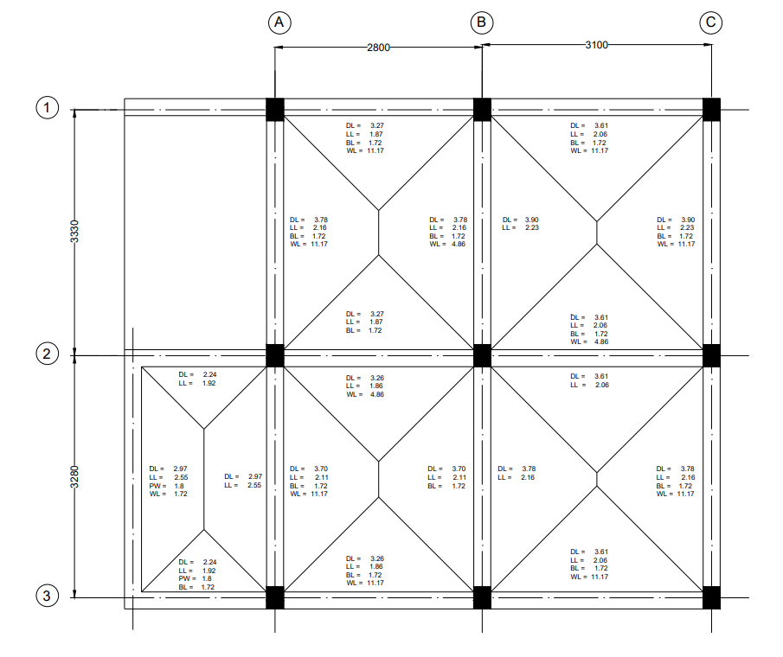
Figure 1: Beam Layout
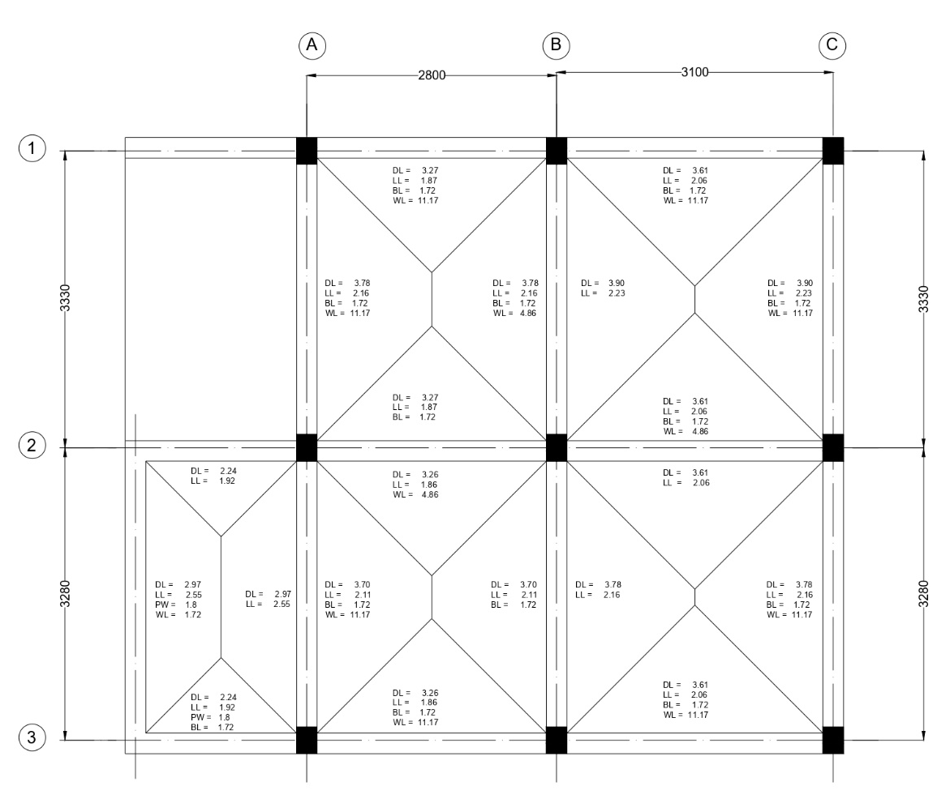
Figure 2: Frames.

Analysis of Frame B1-B2-B3

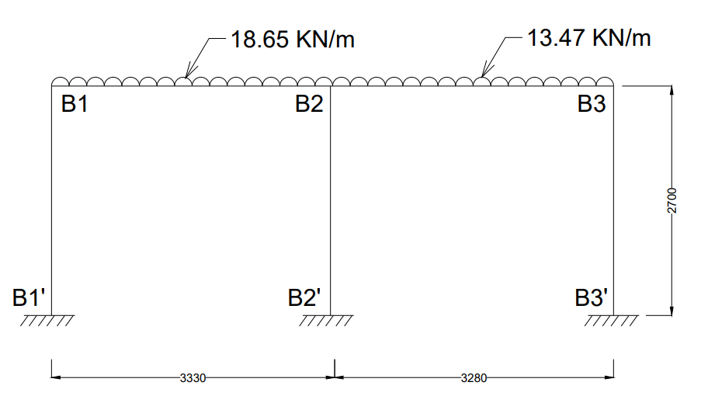
Step 1: Fixed End Moments
MF_{B1B2} = $\frac{-{WL}^{2}}{12}$ = $\frac{-18.65 × {3.33}^{2}}{12}$ = -17.23 KN-m
MF_{B2B1} = $\frac{{WL}^{2}}{12}$ = $\frac{18.65 × {3.33}^{2}}{12}$ = +17.23 KN-m
MF_{B2B3} = $\frac{-{WL}^{2}}{12}$ = $\frac{-13.47 × {3.28}^{2}}{12}$ = -12.08 KN-m
MF_{B3B2} = $\frac{{WL}^{2}}{12}$ = $\frac{13.47 × {3.28}^{2}}{12}$ = +12.08 KN-m
Fixed end moments in All the columns are zero.
i.e,
MF_{B1B1՛ =} MF_{B1՛B1} = MF_{B2B2՛ =} MF_{B2՛B2 =} MF_{B3B3՛ =} MF_{B3՛B3} = 0

Step 2: Rotation Factor $\left(R.F = -\frac{1}{2} \left(\frac{k}{Σk}\right) \right)$, $\left(k= \frac{4EI}{L}\right)$
Joints | Members | Stiffness ($k$) | $$Σk$$ | R.F
B1 | B1B2 | 1.201EI | 2.682EI | -0.224
B1 | B1B1՛ | 1.481EI | 2.682EI | -0.276
B2 | B2B1 | 1.201EI | 3.902EI | -0.154
B2 | B2B3 | 1.220EI | 3.902EI | -0.156
B2 | B2B2՛ | 1.481EI | 3.902EI | -0.190
B3 | B3B2 | 1.220EI | 2.701EI | -0.226
B3 | B3B3՛ | 1.481EI | 2.701EI | -0.274

Stiffness ($k$) $\left(k=\left(\frac{4EI}{L}\right)\right)$
K_{B1B2} = $\left(\frac{4EI}{3.33}\right)$ = 1.201EI
K_{B1B1՛} = $\left(\frac{4EI}{2.7}\right)$ = 1.481EI
K_{B2B1} = $\left(\frac{4EI}{3.33}\right)$ = 1.201EI
K_{B2B3} = $\left(\frac{4EI}{3.28}\right)$ = 1.220EI
K_{B2B2՛} = $\left(\frac{4EI}{2.7}\right)$ = 1.481EI
K_{B3B2} = $\left(\frac{4EI}{3.28}\right)$ = 1.220EI
K_{B3B3՛} = $\left(\frac{4EI}{2.7}\right)$ = 1.481EI
Sum of Stiffness ∑$k$ at Joints
B1: 1.201EI + 1.481EI = 2.682EI
B2: 1.201EI + 1.220EI + 1.481EI = 3.902EI
B3: 1.220EI + 1.481EI = 2.701EI
Rotation Factor $\left(R.F = -\frac{1}{2} \left(\frac{k}{Σk}\right) \right)$
R.F_{B1B2} = $-\frac{1}{2} \left(\frac{1.201}{2.682EI}\right)$ = -0.224
R.F_{B1B1՛} = $-\frac{1}{2} \left(\frac{1.481EI}{2.682EI}\right)$= -0.276
R.F_{B2B1} = $-\frac{1}{2} \left(\frac{1.201EI}{3.902EI}\right)$ = -0.154
R.F_{B2B3} = $-\frac{1}{2} \left(\frac{1.220EI}{3.902EI}\right)$ = -0.156
R.F_{B2B2՛} = $-\frac{1}{2} \left(\frac{1.481EI}{3.902EI}\right)$ = -0.190
R.F_{B3B2} = $-\frac{1}{2} \left(\frac{1.220EI}{2.701EI}\right)$ = -0.226
R.F_{B3B3՛} = $-\frac{1}{2} \left(\frac{1.481EI}{2.701EI}\right)$ = -0.274

Step 3: Displacement Factor $\left(D.F = -\frac{3}{2} \left(\frac{k}{Σk}\right) \right)$
Storey | Members | $$k$$ | $$Σk$$ | D.F
1 | B1B1՛ | 1.481EI | 4.444EI | -0.5
1 | B2B2՛ | 1.481EI | 4.444EI | -0.5
1 | B3B3՛ | 1.481EI | 4.444EI | -0.5

Stiffness ($k$) $\left(k=\left(\frac{4EI}{L}\right)\right)$
K_{B1B1՛} = $\left(\frac{4EI}{2.7}\right)$ = 1.481EI
K_{B2B2՛} = $\left(\frac{4EI}{2.7}\right)$ = 1.481EI
K_{B3B3՛} = $\left(\frac{4EI}{2.7}\right)$ = 1.481EI
Sum of Stiffness ∑$k$ at Storey
∑$k$ = 1.481EI + 1.481EI + 1.481EI = 4.444EI
Displacement Factor $\left(D.F = -\frac{3}{2} \left(\frac{k}{Σk}\right) \right)$
D.F_{B1B1՛} = $-\frac{3}{2} \left(\frac{1.481EI}{4.444EI}\right)$= -0.5
D.F_{B2B2՛} = $-\frac{3}{2} \left(\frac{1.481EI}{4.444EI}\right)$ = -0.5
D.F_{B3B3՛} = $-\frac{3}{2} \left(\frac{1.481EI}{4.444EI}\right)$ = -0.5

Rotation and Displacement Contribution

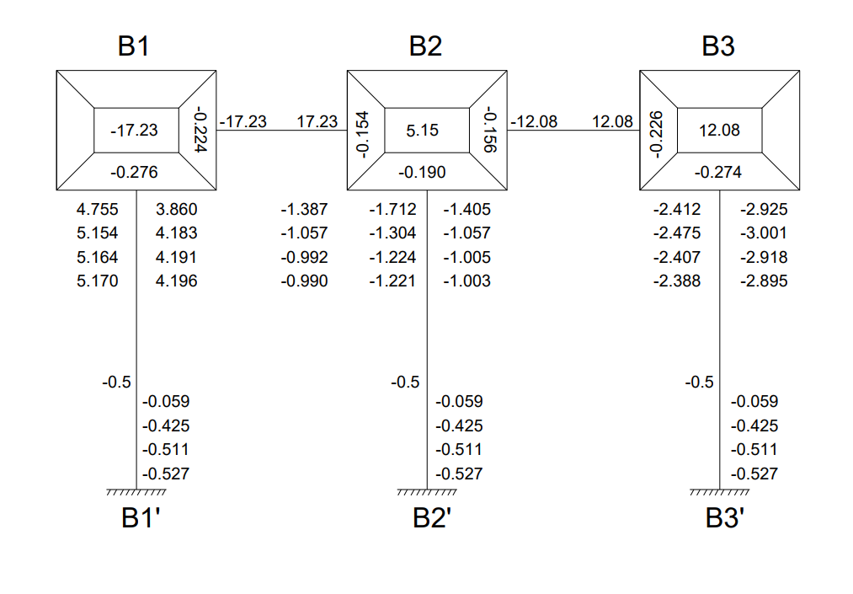
Cycle 1
Joint Rotation $\left(C.V. = R.F × \left[∑FEM+NCV+FCV\right]\right)$
M_{B1B2} = -0.224 × [-17.23 + 0 + 0] = 3.860
M_{B1B1՛} = -0.276 × [-17.23 + 0 + 0] = 4.755
M_{B2B1} = -0.154 × [5.15 + 3.860 + 0] = -1.387
M_{B2B3} = -0.156 × [5.15 + 3.860 + 0] = -1.405
M_{B2B2՛} = -0.190 × [5.15 + 3.860 + 0] = -1.712
M_{B3B2} = -0.226 × [12.08 + (-1.405) + 0] = -2.412
M_{B3B3՛} = -0.274 × [12.08 + (-1.405) + 0] = -2.925
Displacement Contribution
For All Columns $\left(R.V. = D.F × \left[∑Rotations Contribution at Columns\right]\right)$
M_{B1B1՛} = M_{B2B2՛} = M_{B3B3՛} = -0.5 $×$ (4.755 + (-1.712) + (-2.925)) = -0.059

Cycle 2
Joint Rotation $\left(C.V. = R.F × \left[∑FEM+NCV+FCV\right]\right)$
M_{B1B2} = -0.224 × [-17.23 + (-0.059) + (-1.387)] = 4.183
M_{B1B1՛} = -0.276 × [-17.23 + (-0.059) + (-1.387)] = 5.154
M_{B2B1} = -0.154 × [5.15 + (-0.059) + 4.183 + (-2.412)] = -1.057
M_{B2B3} = -0.156 × [5.15 + (-0.059) + 4.183 + (-2.412)] = -1.070
M_{B2B2՛} = -0.190 × [5.15 + (-0.059) + 4.183 + (-2.412)] = -1.304
M_{B3B2} = -0.226 × [12.08 + (-0.059) + (-1.070)] = -2.475
M_{B3B3՛} = -0.274 × [12.08 + (-0.059) + (-1.070)] = -3.001
Displacement Contribution
For All Columns $\left(R.V. = D.F × \left[∑Rotations Contribution at Columns\right]\right)$
M_{B1B1՛} = M_{B2B2՛} = M_{B3B3՛} = -0.5 $×$ (5.154 + (-1.304) + (-3.001)) = -0.425

Cycle 3
Joint Rotation $\left(C.V. = R.F × \left[∑FEM+NCV+FCV\right]\right)$
M_{B1B2} = -0.224 × [-17.23 + (-0.425) + (-1.057)] = 4.191
M_{B1B1՛} = -0.276 × [-17.23 + (-0.425) + (-1.057)] = 5.164
M_{B2B1} = -0.154 × [5.15 + (-0.425) + 4.191 + (-2.475)] = -0.992
M_{B2B3} = -0.156 × [5.15 + (-0.425) + 4.191 + (-2.475)] = -1.005
M_{B2B2՛} = -0.190 × [5.15 + (-0.425) + 4.191 + (-2.475)] = -1.224
M_{B3B2} = -0.226 × [12.08 + (-0.425) + (-1.005)] = -2.407
M_{B3B3՛} = -0.274 × [12.08 + (-0.425) + (-1.005)] = -2.918
Displacement Contribution
For All Columns $\left(R.V. = D.F × \left[∑Rotations Contribution at Columns\right]\right)$
M_{B1B1՛} = M_{B2B2՛} = M_{B3B3՛} = -0.5 $×$ (5.164 + (-1.224) + (-2.918)) = -0.511

Cycle 4
Joint Rotation $\left(C.V. = R.F × \left[∑FEM+NCV+FCV\right]\right)$
M_{B1B2} = -0.224 × [-17.23 + (-0.511) + (-0.992)] = 4.196
M_{B1B1՛} = -0.276 × [-17.23 + (-0.511) + (-0.992)] = 5.170
M_{B2B1} = -0.154 × [5.15 + (-0.511) + 4.196 + (-2.407)] = -0.990
M_{B2B3} = -0.156 × [5.15 + (-0.511) + 4.196 + (-2.407)] = -1.003
M_{B2B2՛} = -0.190 × [5.15 + (-0.511) + 4.196 + (-2.407)] = -1.221
M_{B3B2} = -0.226 × [12.08 + (-0.511) + (-1.003)] = -2.388
M_{B3B3՛} = -0.274 × [12.08 + (-0.511) + (-1.003)] = -2.895
Displacement Contribution
For All Columns $\left(R.V. = D.F × \left[∑Rotations Contribution at Columns\right]\right)$
M_{B1B1՛} = M_{B2B2՛} = M_{B3B3՛} = -0.5 $×$ (5.170 + (-1.221) + (-2.895)) = -0.527

Step 4: Final End Moments
M_{ij} = FEM + 2×M_{ij} (Near end Rotation) + M_{ji} (Far end Rotation) +M՛՛ (Displacement)
Beams (No Sway M՛՛= 0)
M_{B1B2} = -17.23 + 2(4.196) + -0.99 = -9.83
M_{B2B1} = 17.23 + 2(-0.99) + 4.196 = 19.45
M_{B2B3} = -12.08 + 2(-1.003) + (-2.388) = -16.47
M_{B3B2} = 12.08 + 2(-2.388) + (-1.003) = 6.30
Column (With Sway M՛՛= (-0.527))
M_{B1B1՛} = 0 + 2(5.170) + 0 + (-0.527) = 9.81
M_{B1՛B1} = 0 + 2(0) + 5.170 + (-0.527) = 4.64
M_{B2B2՛} = 0 + 2(-1.221) + 0 + (-0.527) = -2.97
M_{B2՛B2} = 0 + 2(0) + (-1.221) + (-0.527) = -1.75
M_{B3B3՛} = 0 + 2(-2.895) + 0 + (-0.527) = -6.32
M_{B3՛B3} = 0 + 2(0) + (-2.895) + (-0.527) = -3.42
Equilibrium Check
Joint B1 = M_{B1B2} + M_{B1B1՛} = -9.83 + 9.81 = -0.02 ≈ 0
Joint B2 = M_{B2B1} + M_{B2B3՛ +} M_{B2B2՛} = 19.45 + (-16.47) + (- 2.97) = 0.01 ≈ 0
Joint B3 = M_{B3B2} + M_{B3B3՛} = 6.30 + (–6.32) = –0.02 ≈ 0
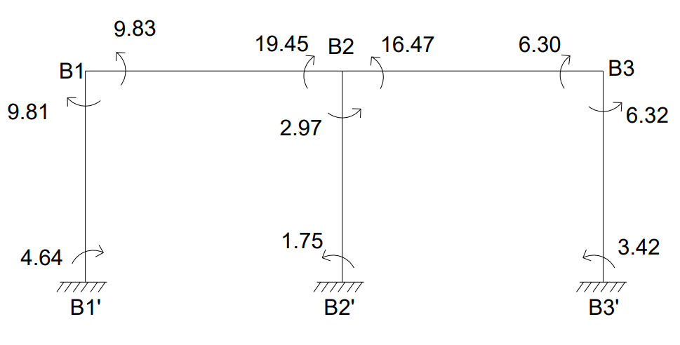
CALCULATION BENDING MOMENT
BM_{B1B2} = $\frac{{WL}^{2}}{8}$ = $\frac{{18.65 ×3.33}^{2}}{8}$ = 25.85KN-m
BM_{B2B3} = $\frac{{WL}^{2}}{8}$ = $\frac{{13.47 ×3.28}^{2}}{8}$ = 18.11KN-m
BENDING MOMENT DIAGRAM
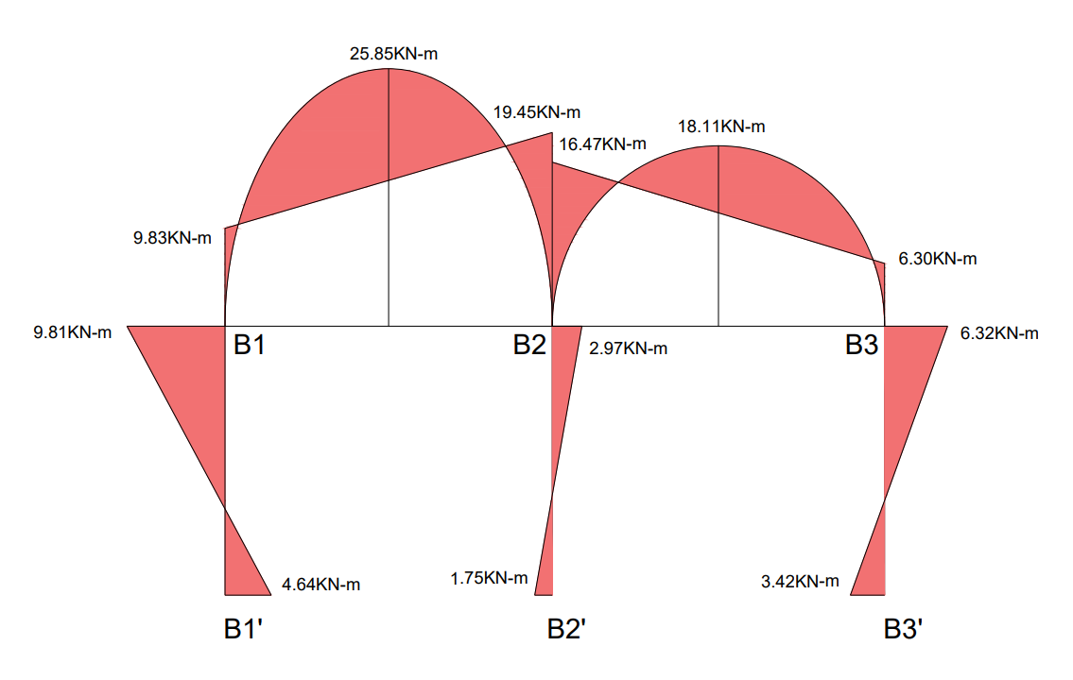
CALCULATION OF REACTIONS
SPAN B1-B2
Length (L) = 3.33m, UDL (W) = 18.65KN/m
Simply Supported Reactions:
R_{total} = $\frac{WL}{2}$ = $\frac{18.65 ×3.33}{2}$ = 31.05KN
Reaction Due to End Moments:
R_{moments} = $\frac{M_{B2B1}- M_{B1B2)}}{L}$ = $\frac{19.45 - 9.83}{3.33}$ = 2.89KN
Final Reactions:
R_{B1} = R_{total} – R_{moments} = 31.05 – 2.89 = 28.16KN
R_{B2(Left)} = R_{total} + R_{moments} = 31.05 + 2.89 = 33.94KN

SPAN B2-B3
Length (L) = 3.28m, UDL (W) = 13.47KN/m
Simply Supported Reactions:
R_{total} = $\frac{WL}{2}$ = $\frac{13.47 ×3.28}{2}$ = 22.10KN
Reaction Due to End Moments:
R_{moments} = $\frac{M_{B2B3}- M_{B3B2)}}{L}$ = $\frac{16.47- 6.30}{3.28}$ = 3.10KN
Final Reactions:
R_{B2(Right)} = R_{total} + R_{moments} = 22.10 + 3.10 = 25.2KN
R_{B3}= R_{total} – R_{moments} = 22.10 – 3.10 = 19KN
Total Reactions:
Reaction at Column B1 (R_{B1}) = 28.16KN
Reaction at Column B2 (R_{B2}) = R_{B2(Left)} + R_{B2(Right)} = 33.94 + 25.2 = 59.14KN
Reaction at Column B3 (R_{B3}) = 19KN
